***Sports Club***

** To have a healthy life, it is better to join a sports club **

***Team member name:*** MAZHAR FEIZI

HARPREET SINGH

KAWALPREET KAUR

AMRITPAL SINGH

Table of Contents

Section 1: System Idea in a Nutshell 4

Section 2 Story behind the idea 6

Section 3: Information offered to the Users 8

Section 4: Where is the data coming from? 9

Section 5: The Target Users 10

Section 6: Similar Systems 11

Section 7.Benefits to the users: 14

Section 8.Diagram and visual/logical designs: 17

Section 9.Data flow diagram 21

Section 10: Team Recognition 21

Section 11. Implementation Plan 23

Great Start with the DIAGRAM FOR SPORTS CLUB MANAGEMENT SYSTEM which includes the users, site planning (location), designs, benefits, financial reports, stakeholders, skills, drawbacks so on that will give overview about the project and will define further with explanation.

# Section 1: System Idea in a Nutshell

* Overview of the System

The **Sports Club Management System** is developed to simplify and optimize the functioning of sports clubs by offering a unified platform to handle every aspect of the club’s operations. The system enables efficient management across different areas such as sports activities, player information, tournaments, financial matters, matches, teams, staff members, and champions.

**Main Features and Capabilities:**

* **Unified Platform:** Brings together all club activities into a single platform, making it easier to manage and access information.
* **Player Management:** Facilitates the registration process and allows tracking of player performance and statistics.
* **Tournament Scheduling:** Helps organize and manage tournaments, including setting up schedules, creating brackets, and recording results.
* **Financial Management:** Keeps track of expenses and revenues, providing financial reports to ensure responsible financial oversight.
* **Match Management:** Assists in scheduling matches, recording results, and maintaining a historical database for future reference.
* **Team Management:** Handles team rosters, coaching staff assignments, and training schedules.
* **Recognition of Champions:** Monitors achievements and awards, highlighting the success of the club and its members.

This system is designed to improve the efficiency of sports club operations, enabling the club to concentrate more on athletic performance and less on administrative work.

This illustration captures the full scope of the Sports Club Management System, emphasizing key features such as unified management, player monitoring, tournament organization, financial oversight, and team coordination. The image portrays a streamlined digital interface that is both modern and easy to navigate.

# Section 2 Story behind the idea

Sports clubs encounter various challenges when it comes to managing their operations effectively. These challenges often include coordinating schedules, managing player data, handling finances, and organizing tournaments. Traditionally, these tasks require a lot of manual work, which can lead to mistakes and inefficiencies.

**Why the System Was Developed:**

* **Complexity in Coordination:** Managing different aspects of a sports club, such as players, teams, and tournaments, can be overwhelming and difficult to manage without the right tools.
* **Data Handling:** Keeping track of player statistics, financial records, and match results is challenging without a centralized system.
* **Efficiency Gains:** A streamlined system reduces the time and effort needed for administrative tasks, allowing staff and managers to focus more on enhancing the club's performance.

By addressing these issues, the Sports Club Management System aims to provide a comprehensive solution that improves club operations and enhances the experience for everyone involved, from players to staff members.

This image highlights the common issues that sports clubs encounter, including scheduling clashes, handling large amounts of data, and managing various aspects simultaneously. The scene illustrates the complexities and lack of organization, underscoring the importance of a more efficient management system.

# Section 3: Information offered to the Users

The Sports Club Management System provides users with a broad range of information and functionalities, ensuring that every aspect of the club is easily accessible and manageable.

**Details on What Users Can Access:**

* **Players:** Users can view comprehensive player profiles, including personal information, performance metrics, and historical data.
* **Tournaments:** Users have access to details about upcoming and past tournaments, including schedules, results, and standings.
* **Financials:** Users can view financial records, track expenses, and generate reports for budgeting and financial planning.
* **Matches:** Users can access match schedules, results, and statistics, helping teams prepare better and analyze their performance.
* **Teams:** The system offers extensive team management features, including roster details, coaching staff information, and training schedules.
* **Champions:** The system also highlights the achievements of teams and players, fostering a culture of excellence and recognition within the club.

This system is designed to empower users by providing them with the necessary tools to effectively manage and grow their sports clubs.



This illustration displays the range of information available to users, such as player details, tournament timelines, financial summaries, match data, team line-ups, and records of achievements. The icons and visuals are arranged to represent an intuitive interface that offers easy access to various types of information.

# Section 4: Where is the data coming from?

**Club Manager:** The information like player and coach names, dates of birth, positions, and dates of employment and match details, such as dates, opponents, and scores are provided by the Manager.

**Medical Staff:** They provide up-to-date information about athlete injuries and medical conditions making sure their information is up to date.

**Match Report:** The match reports are provided by the coach which has all the information like the match details, players playing that match, their statistics and performance.

**Financial records:** The financial department provides data on income and expenses, including transaction details such as amounts, dates and descriptions. This information is important for tracking the financial health and managing the club's budget. Scouting reports:

**Scouts:** Scouts provide performance summaries and evaluations of prospects. This data will be used to assess the athlete's strength and performance, which will help in the recruitment process. External sources:

All the data will be handwritten by us.

# Section 5: The Target Users

**Club Managers:** Manages the overall operation of the club, ensuring smooth coordination between the various departments. Use: Enter and update player and coach information, schedule matches and monitor financial data. They also generate reports and analyze data for decision making.

**Trainers:** Oversees team performance, develops training programs and manages player development. Use: Record and review match performance data, track participation in training and analyze player statistics to adjust strategies and training programs.

**Medical staff:** Monitor player health and fitness, provide medical care and manage injury rehabilitation. Use: Update injury statuses, record medical notes and track players' fitness levels to inform training and match preparation.

**Finance Department:** Manages the financial health of the club, including budgeting, accounting and financial planning. Use: Enter financial transactions, monitor income and expenses, and generate financial reports for budgeting and strategic planning.

**Scouts:** Identify and evaluate potential recruits to strengthen the team. Use: Enter research reports, including performance summaries and prospect evaluations, and analyze data to support recruiting decisions.

**Team Leaders:** Coordinate team activities, liaise with other departments and assist coaches in team management. Use: Access complete player and match data to assist team management and ensure transparent communication between coaches, players and administrators.

**Board members/owners:** Oversees the strategic direction and overall success of the club. Use: Review high-level reports on team performance, financial health and player development to make informed strategic decisions.

# Section 6: Similar Systems

Sports have a great history when we consider.   The special features of sports, its demarcation from business, and its effective management are considered as explicitly or implicitly by most authors when they write anything about social, cultural development. Sports unique nature and context have been highlighted especially. Sports is additionally complicated by the fact that it exists in both commercial and not – for – profit forms like other cultural services such as theatre, art, music, healthcare and education. Some special features of sports make it more unique by culturally and special by commercially.

**  
There are several aspects to play sports very different from various things such as its effective skills as well strategy which will quite be helpful to run a successful sports club and make it more famous. First here are some qualities which are required such as:

* **Leadership:** firstly, leader must encourage the club members and work hard to achieve their goals. Secondly, as a leader one should not only gives orders to others instead of this you have to listen and try to understand the other’s concept so, but others may also get motivation from the leader and perform their best.

* **Sports Club Management App:**
* In this cutting edge era everything become digitalized so with the time everything grows Fastly so here it is a suggestion or idea that if sports club introduced special apps for their users which is very helpful and time consuming because if anyone wants to enrol themselves so they can do easily or get some knowledge by viewing the feedback or any necessary information so they can. It makes the management system much more effective.

Everything have pros and cons either a sports club or any other no matters but if a lot of benefits provided to the users then it is sure that it has some drawbacks also so here first talk about advantages later then disadvantages:

PROS:

1. No doubt, if you join sports club, you will spend most the time in running, walking, exercises, games and performing a multitude tasks. This is good for health, and you remain positive as well.

2. It can help to enhance your skills also such as teamwork, leadeship, communication, patience level and professional skills as a player.

3. They experience more exposure by travelling to tournaments and connect to different people(leagues). Having a opportunity to travel is also a blessing because one can experience good things and make memories. Players have chances to show their talents.

CONS:

1.Somewhere pressure exists it can be peer pressure or may be to stand out and be a best player because nowadays, competition is very high, and everyone want to become perfect which raise jealousy also.

2. Club sports are not easy owe to its expenses. Here needs financial sacrifices to participate. You will be financially strong first.

# Section 7.Benefits to the users:

**Advantages of using different stakeholders:**

A stakeholder first the word defines all the users, owners, suppliers, employee it may be a party or any individual one. Participants are the main stakeholders in sports because if they perform well a success and profit will come to the organization. It plays vital role in success and failure.

**IMPROVED EFFICIENCY, COMMUNICATION AND MANAGEMENT:**

Everyone wants recognition for their work either they are handling small or big responsibility no matters. Volunteers should get some recognition and awards for their efforts so they may give their best to do something big. BEST WORKER OF THE YEAR award should be introduced so others may be inspired too and put more efforts to get rewards.

* DO SOMETHING DIFFERENT to make your club more famous and unique and provide facilities to staff members and players also. Ensure that full safety is providing to all the members who are linked with the club and parents cannot worry about their children , asking members to give feedback so they may know about their drawbacks and their good things also, They should gather information and reviews of people which will help to better decision making and do required changes which are in demand ......
* **COMMUNICATION:**

Communication plays a significant role in every field, even daily to daily life but here we talk about communication in sports club here it is the main root that holds a sports club together. Have a clear and open communication between club leaders and other members is very important. It’s not just about conveyed your message or sharing information it's also about listening the opinions and values through which everyone can easily share their ideas and concerns. Social media, online communication platforms, meeting links are ways to keep members in touch and keep communication alive.



* **EFFECTIVE FINANCIAL MANAGEMENT:**

It is important to have a clear and real budget, manage income and other expenses responsibility and ready for additional funding also when need. First the club need a bank account, a cashbook is a proof (journal) in which all the club's receipts and payments are recorded as a proof. The club will require an annual budget for tournaments/ events. Club should provide insurance to their workers/ users, so they feel secure. The choice of insurance company will depend on the policies, cover and costs that they are able to offer the club.

# Section 8. Diagram and visual/logical designs:

* **System architecture:**

Designing and building a new sports club such an impressive achievement because it takes a lot of money, time etc. There are numerous things that need to know while designing a sports club that are highlighted below:

1. Site planning:

First, one should know about the site (location) because sports centre needs open ground /area. It becomes unavoidable to plan your site, you should have proper and open place for your club includes the climate of that particular place.

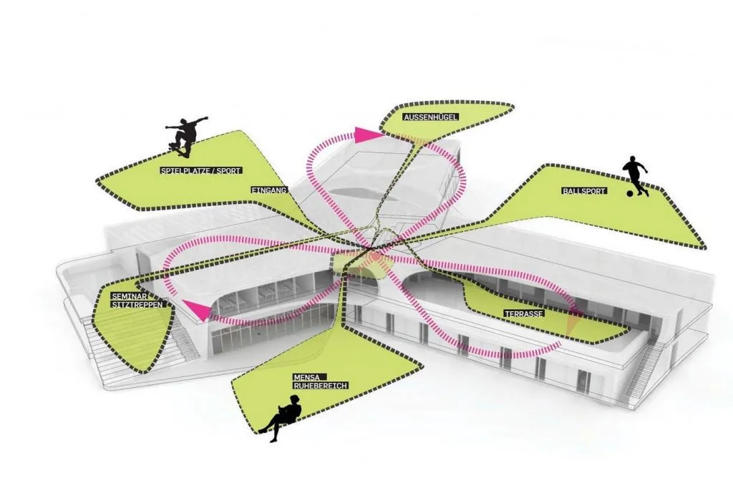

* **CONSTRUCTION MATERIAL:**

The material of construction to build a sports club can be highly expensive and mainly depending on the amenities, programmes provide to the users/players. The use of materials should be available locally and in abundances. It is advise that constructors should use that material which is 100 percent pure and easily available, not in shortage and guaranteed .

* **FUTURE EXPANSION:**

It is crucial to think that in future if there is need to expand the sports club widely, they can easily do that if they have enough space for future expansion. No doubt, it takes a lot of space but one must think about for future projects also.

**USER INTERFACE DESIGN FOR SPORTS CLUB:**

* Responsive design: Ensuring the interface is accessible and functional across various devices and screens.
* Accessibility:  Ensuring the interface assemble with accessibility standards to survive users with disabilities.
* Feedback Mechanisms: proper feedback provides to users with confirmation of actions and error/mistaken notifications.
* Content Uploads: View the type of content uploaded by users/players, such as photos, videos, or documents.
* Report Generation: Observe the generation and giving out the reports to stakeholders, such as financial reports or performance reports so on.

# Section 9.Data flow diagram

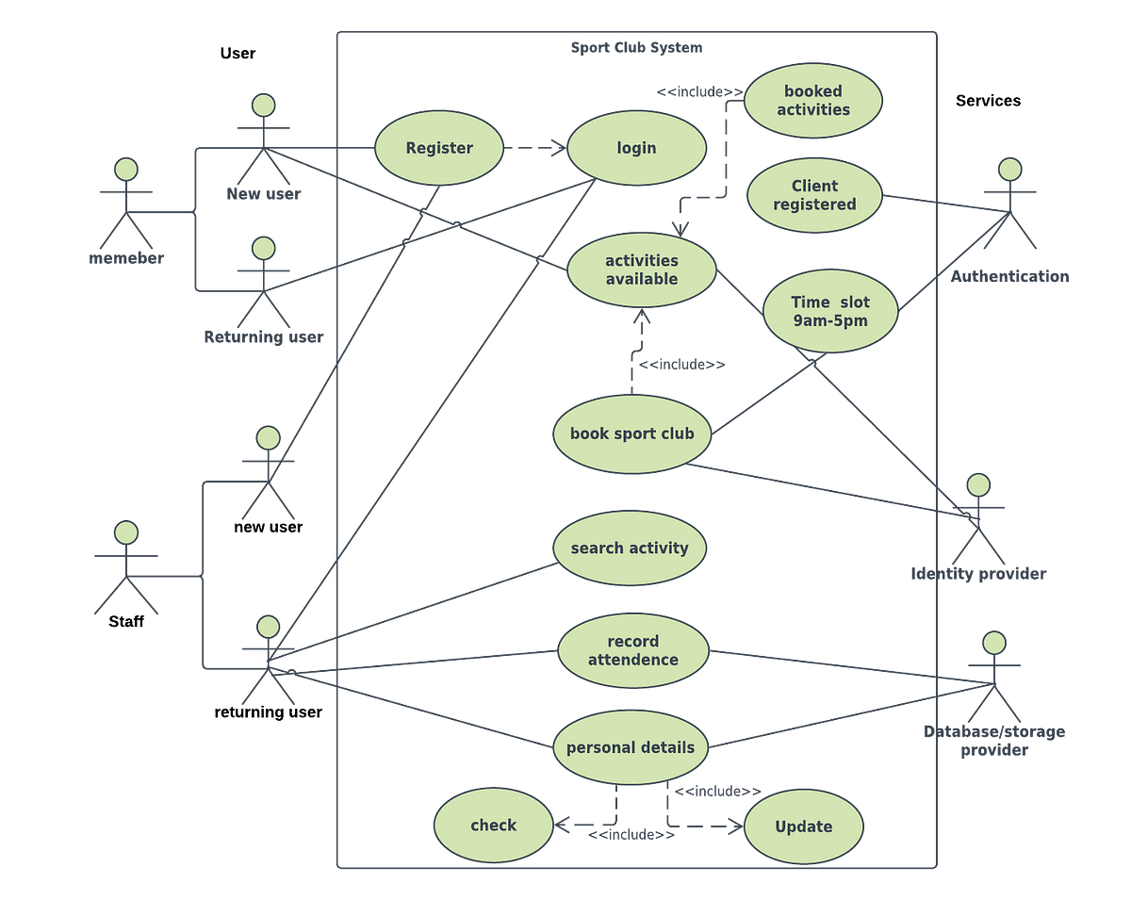

This diagram illustrates the all steps which are require to run a sports club from starting . Here one side is users and other side is services that are provided by organizers . firstly , if anyone want to join a club that person is called user and they have to register themselves to become member of that club once you become a member you can login anytime for booking your activities and came to know about the services , time slots, search different activities and enrol yourself according to your requirements and your all data store including personal details , attendance as a record and you may able to know all the new updates that will implements in future if you are in touch.

# Section 10: Team Recognition

The team power is another strength of our project, and each member of the team is an expert in accomplishing the goal of implementing this system.

 Like I have named the people by my self only for example.

Roles and Parts Played by Every Individual.

Amandeep belongs to the project manager professional specialization.

**Role:** Usually, he is involved with the project from its design phase to its implementation.

Contributions: Directs team activities, monitor time, checks that goals are achieved on time and communicates with other teams, checking the project relevance to organizational goals.

I will be following this up with Rohit – Lead Developer.

**Role:** These managers head the development teams and are also in charge of the technical construction plan of the program.

Contributions: Is responsible for the logical layout of the system and is involved in the definition of standards within the coding and in checking the quality of the code; is also solves numerous high level technical problems.

Amrit is the Backend Developer

**Role:** Concerned with handling the back end of an application and manipulation of data in a database.

Contributions: Designs and implements APIs, deals with the database and maintains the servers.

Gurpreet is a Frontend Developer

**Role:** In charge of the development of the side of the application that the client uses.

Contributions: Follow and execute the submitted UI/UX designs, and makes the app as receptive and engaging, and merges the front-end components with the back-end services.

Tanveer who is a QA Engineer.

**Role:** Ensures that the final system that gets delivered to the end-users is of a high quality and is very reliable.

Contributions: Creates, implement test and prepare test plan, observe the products and report bugs and work in conjunction with developers.

A DevOps Engineer who goes by the name of Harpreet.

**Role:** Is responsible for the project of the system infrastructure. Contributions: Manages the application deployments and performance metrics while guaranteeing availability and horizontal scalability of the application.

Gagan User Interface\User Experience Designer

**Role:** Is centred around usability and the look and feel of the program.

Contributions: Designs the layout of the Website, and develops the wire frames and the prototypes, as well as undertaking user research to validate that the final design image is friendly to the end user and beautiful to behold.

# Section 11. Implementation Plan

**Developing and Deploying a System:** A Timetable and Checklist

 Planning Phase **(1 month)**

 Describe objectives and specifications of a project.

 Bring together the people who can be of help and give them their part to play.

 Identify major goals and set up project management with the schedule and deadlines.

 Design Phase **(2 months)**

 Create wireframes and prototypes.

 Design system architecture.

 Analyse and possibly approve the documents concerning the design.

 Development Phase **(4 months)**

**Backend development:** Establish the databases, construction of APIs, and the implementation of server-side scripting.

**Frontend development:** Implemented building of user interfaces, interaction with backend services and making sure that the whole thing runs smoothly and fast.

 Carry out routine code review as well as incorporation test.

 Testing Phase **(1 month)**

 Carryout extensive testing (unit, integration and system testing).

 Identify and fix bugs.

 Carry out usability testing.

 Deployment Phase **(1 month)**

 Set up production environment.

 Put the system into live use cross organizational.

 Check the system logs and address if there is anything wrong.

 Post-Deployment Phase (Ongoing)

 Ensure maintenance and follow up is continually done.

 Collect data from the users, and measure system effectiveness.



This image captures a lively moment showcasing the success and unity of a well-managed sports club, with key elements like a trophy, a jubilant team, and a coach analyzing data on